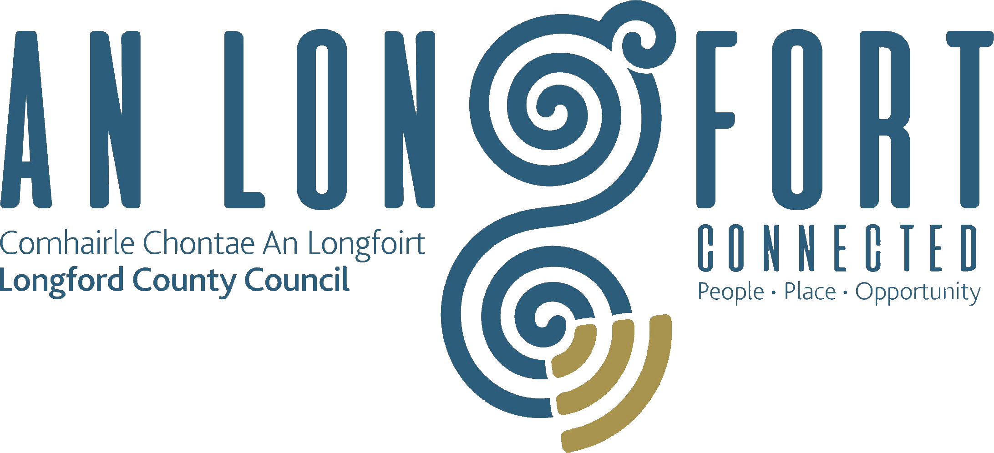

Minutes of Combined February/March Monthly Meeting of Longford County Council
held in the Council Chamber, Aras an Chontae, Great Water Street, Longford on
Wednesday, 6th March 2019 at 4.00 p.m.
____________________________________________________________________

PRESIDING: Councillor Luie McEntire, Cathaoirleach.

MEMBERS PRESENT: Councillors – Paraic Brady, John Browne, Seamus Butler, Mick Cahill, Micheál Carrigy, Mark Casey, Gerard Farrell,
Joe Flaherty, Gerard Hagan, Colm Murray, Peggy Nolan, Pat O’Toole, P.J. Reilly, P. Ross and
Gerry Warnock.

IN ATTENDANCE: Mr. John McKeon, Deputy Chief Executive.
Mr. John Brannigan, Director of Services.
Ms. Barbara Heslin, Director of Services.
Mr. Michael Nevin, Head of Enterprise.
Ms. Louise Kiernan, Senior Executive Planner.

APOLOGIES Mr. Paddy Mahon, Chief Executive.
Councillors Martin Mulleady and Mae Sexton.

MEETINGS
ADMINISTRATOR: Ms. Anne Lee

ADOPTION OF MINUTES.

On the proposal of Councillor J. Browne seconded by Councillor P. Nolan, the Minutes of Special Meeting of Longford County Council held on the 9th January 2019, as circulated, were confirmed and adopted.

On the proposal of Councillor S. Butler seconded by Councillor P. Nolan, the Minutes of Monthly Meeting of Longford County Council held on the 16th January 2019, as circulated, were confirmed and adopted

MATTERS ARISING FROM MINUTES.

None.

CHIEF EXECUTIVE ORDERS

The Chief Executive Orders, as circulated, were noted.

MONTHLY MANAGEMENT REPORT.

The Monthly Management Report, as circulated, was noted.

CORPORATE POLICY GROUP MINUTES.

The adopted Minutes of Corporate Policy Group Meeting held on the 12th December 2018, as circulated, were noted.

ECONOMIC AND COMMUNITY DEVELOPMENT, HUMAN RESOURCES & CORPORATE SERVICES, CULTURAL & RECREATIONAL SERVICES.

Minutes of Economic Development and Enterprise Strategic Policy Committee

The adopted Minutes of Economic Development and Enterprise Strategic Policy Committee Meetings held on the 17th September and 12th November 2018, as circulated, were noted.

Amendment to the Business Incentive Scheme - circulated.

On the proposal of Councillor S. Butler seconded by Councillor M. Carrigy, it was unanimously agreed to adopt Amendment to the Business Incentive Scheme subject to the following changes -

- The Addendum will be effective from 1 January 2019 until 31 December 2021.
- Businesses eligible for the main BIS scheme may not apply for support under the new Addendum to the scheme.
- In the Terms and Conditions on Shop-front Grant, 'A claim under the Shopfront Grant element of the scheme may only be made once in every five year period' be removed.
- The operation of the scheme be reviewed by the Economic Development and Enterprise Strategic Policy Committee during the period 1 January 2019 to
31 December 2021.

Diaspora Strategy.

On the proposal of Councillor S. Butler seconded by Councillor M. Carrigy, it was unanimously agreed to adopt Draft Diaspora Strategy, as circulated.

Longford Local Electoral Areas and Municipal Districts Order 2018.

The County of Longford Local Electoral Areas and Municipal Districts Order 2018, as circulated, was noted.

Director’s Report – Eastern & Midland Regional Assembly. Draft Regional Spatial
and Economic Strategy 2019-2031 – circulated.

B. Heslin briefed the members on The Director’s Report – Eastern & Midland Regional Assembly – on the Draft Regional Spatial and Economic Strategy 2019-2031.

Barbara stated that the members of the Regional Assembly, at the meeting of 1st March 2019, considered the submissions received during the public consultation of the draft RSES and proposed a number of amendments. In terms of the outcome from this meeting, in relation to Longford there is general satisfaction that most issues outlined in previous extensive submissions have been addressed.

Proposals for a 25% headroom population allocation to the counties of Longford, Offaly and Laois, to match the 25% headroom allocation given to the other counties in the EMRA region, were not agreed by the EMRA Executive. The reasoning, as indicated in the Director’s Report, is that the National guidance in the form of the NPF Road Map does not provide for population headroom for these Counties. Therefore, the RSES cannot make provision for same. In an attempt to address this Members proposed the following amendment:-

‘Core Strategies should apply prioritisation measures rather than de-zoning of land where a surplus of lands are identified in existing plans, with regard to the NPF Implementation Roadmap up to 2031. In preparing Core Strategies, account should also be given to the consideration of sequential lands which are suitable for the delivery of housing but may not be forthcoming in the Plan period having regard to 2031 Roadmap targets, subject to proper planning and sustainable development’.

If the amendments agreed by the members are considered material by EMRA, they will be subject to a further minimum 4 week public display and consultation. Following this it is envisaged that the proposed material amendments will be considered by the members at the May meeting of the Assembly.

National Community Weekend Event Fund 2019 – details enclosed.

Barbara gave details regarding the National Community Weekend Event Fund 2019.

This Scheme is a National initiative funded by the Department of Rural & Community Development to support small events that will celebrate, develop and deepen the spirit of community in Ireland. Events will take place over the May Bank Holiday weekend. Closing date for receipt of completed application forms is Friday, 15th March 2019.

AILG Annual Conference.

The Cathaoirleach, Councillor McEntire, referred to the outstanding success of the AILG Annual Conference which was held in the Longford Arms Hotel and thanked all who were involved with the organisation of the event. Special tribute was given to Longford County Council staff member, Inga Pupiniene, who provided support during the Conference and who also designed the handouts etc. which were given to the delegates.

Notice of Motion.

Albert Reynolds Memorial Lecture – Councillor M. Mulleady.

"I propose that former US President, Bill Clinton, be invited to be the keynote speaker at the
next Albert Reynolds Memorial Lecture."

Deferred to the next meeting of Longford County Council.

FINANCE & INFORMATION SYSTEMS.

Public Liability Claims.

It was noted that six Public Liability Claims were received since the last meeting of the Council.

Capital Budget 2019-2021.

J. McKeon gave a comprehensive presentation on the Capital Budget 2019-2021 and replied to queries raised. The Capital Budget 2019 – 2021 was noted by the members.

Local Government Act 2001 - Annual Ethics Declaration.

J. McKeon gave a reminder regarding the return of Annual Ethics Declaration Forms.

Disposal of Plot of Land at Templemichael Glebe, Longford.

On the proposal of Councillor Seamus Butler seconded by Councillor Gerry Warnock, it was unanimously agreed to the disposal of Plot of land at Templmichael Glebe, Longford to John Halnon and Mary Cronin in accordance with the terms of Section 183 of the Local Government Act 2001 issued on the 18th February 2019.

Notice of Motion.

Kevin Bell Repatriation Trust – Councillor M. Mulleady.

"I propose that a letter of thanks and support be sent to the trustees of the Kevin Bell Repatriation Trust. Also, that Longford County Council make a contribution towards the fund in memory of all the families who sought help to get their loved ones home to Ireland for internment, especially the McGee family from Drumlish and the Murphy family from Ballinamuck who with the help of this fund were able be bring their sons, Danny and James, home.”

Deferred to next Longford County Council meeting.

PLANNING, HOUSING, INFRASTRUCTURE, ENVIRONMENT & EMERGENCY SERVICES.

Planning Applications.

The list of Planning Applications received since the January meeting of the Council were noted.

Minutes of Housing Services Strategic Policy Committee.

The adopted Minutes of Housing Services Strategic Policy Committee held on
the 4th December 2018, as circulated, were noted.

Minutes of Infrastructural and Environmental Strategic Policy Committee.

The adopted Minutes of Infrastructural and Environmental Strategic Policy Committee Meeting held on the 5th December 2018, as circulated, were noted.

Draft Waste Presentation Bye-Laws,

On the proposal of Councillor Michael Carrigy seconded by Councillor Peggy Nolan, it was unanimously agreed to adopt the Waste Presentation Bye-Laws, as circulated.

Weir on the River Shannon at Cloondara/Termonbarry.

On the proposal of Councillor M. Carrigy seconded by Councillor P. Nolan, it was unanimously agreed to adopt the following recommendation from the Infrastructure and Environment Strategic Policy Committee -

“That Longford County Council writes to Waterways Ireland requesting that in the event of
Waterways Ireland lodging a planning application in the future for the reinstatement of the weir on the River Shannon at Cloondara/Termonbarry, that consideration be given to including sluice gates into the design of the weir.”

Policy on Decorative Paving and Re-instatement of Footpaths.

On the proposal of Councillor S. Butler seconded by Councillor G. Warnock, it was unanimously agreed to adopt Draft Policy on Decorative Paving and Re-instatement of
Footpaths, as circulated.

Notices of Motions.

Wind Farm Guidelines.

The following Notice of Motion was proposed by Councillor M. Casey and seconded by Councillor S. Butler -

“In respect of the recent Board Na Mona application to Bord Pleanala, that this Council writes to the Minister to put in place a Moratoria on any decision until the new Wind Farm
Guidelines are in place, which are due from the Minister’s office shortly.”

A letter to be forwarded to Bord Pleanala, as agreed.

The following Notice of Motion was proposed by Councillor M. Casey and seconded by Councillor C. Murray -

“That prior to any wind turbines being erected by Bord Na Mona, that this Council gets an independent noise survey done of the bogs where the proposed wind farms are being erected. Thus providing a base line for noise prior to the erection of the wind turbines.”

J. Brannigan stated that the application is currently under consideration by An Bord Pleanala who are the statutory organisation responsible for deciding on the application. Longford County Council are not in a position to carry out any noise surveys. Any noise surveys carried out by Longford County Council would have no benefit to any potential future monitoring of the development.

The following Notice of Motion was proposed by Councillor G. Farrell and seconded by Councillor M. Casey -

“I call on Longford County Council to write to An Bord Pleanala requesting that no permissions be given for wind turbines until the proposed new guidelines are issued by the Department of Housing, Planning & Local Government.”

A letter to be forwarded to Bord Pleanla, as agreed.

GENERAL.

Correspondence – circulated.

Letter dated 24th January 2019 received from Department of Health regarding CervicalCheck was noted.

Letter dated 31st January 2019 received from Department of Health regarding Medical Card
Application process was noted.

Letter dated 31st January 2019 received from HSE regarding Child Phycologists posts was noted.

Letter dated 19th February 2019 received from Department of Housing, Planning and Local
Government regarding criteria for the Rebuilding Ireland Home Loan was noted.

TRAINING.

Report from Corporate Policy Group was noted.

120th Anniversary of Local Democracy.

It was agreed that the names of the Councillors elected to Longford County Council on
22nd April 1899 be read out at the next County Council meeting.

Aoife McGivney.

Tributes were paid to Aoife McGivney, originally from Newtownforbes, who administered CPR to a Dublin Bus Driver who suffered a heart attack while driving through Dublin city centre.

This concluded the business of the meeting.

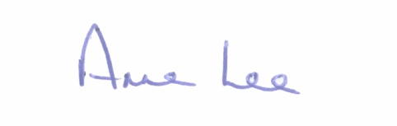

Signed: _______________
Anne Lee,
Meetings Administrator.

Confirmed and adopted at Monthly Meeting of Longford County Council held on the
8th May 2019.

Signed: _______________
Cathaoirleach.

